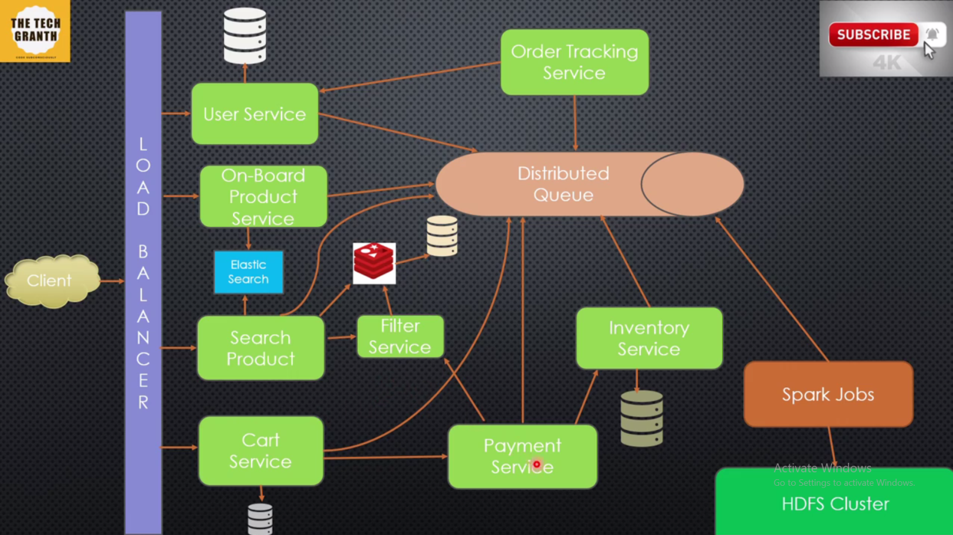

So generally we can divide most of the system design on two parts: 1- Functional 2- Non Functional

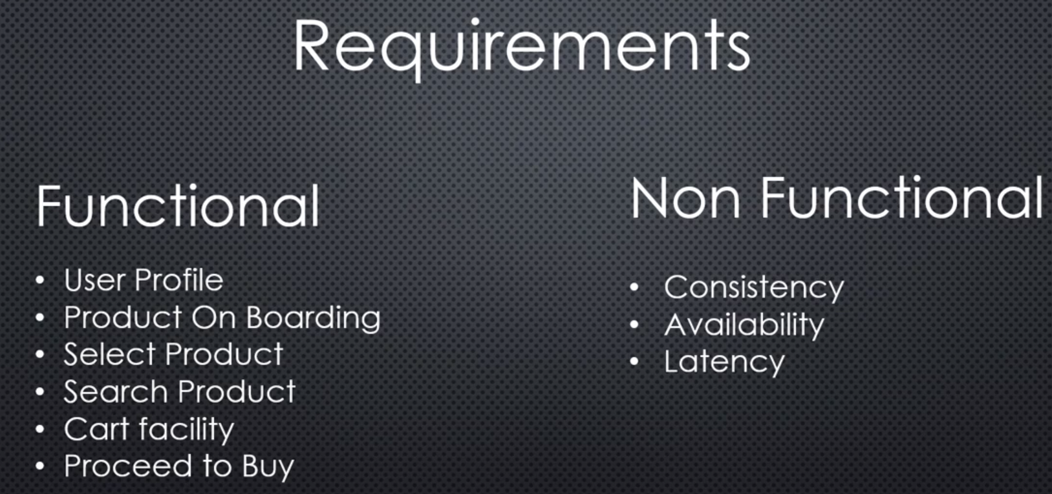

As we can see that based on the requirement we have divided e-commerce design into to two parts.

Functional:

1. **User Profile:** As in most of the e-commerce website every user should have a user profile. So every user should be able to create their own profile. And during the profile creation they should be able to store their name, email address, phone number and their postal address and they should also be given provision to preferred way of payment and it should be able to store their credit card number in a encrypted manner and it should not be allowed to store any confidential data like pin number or CVV number. Once user created their profile and logged in then they should be able land on – onboard product
2. **Product on Boarding:** So here user either can buy a product or can sell the product. So to sell the product user should be able to on board their product.

**Here user either could be buyer or seller, So on boarding the product will be for seller user.**

1. **Search the Product:** So this feature obliviously will be for buyer user, who will select the product. So there should be an option to search the product and select the product. So based on the, text typed in the search box, the user should be able to get some production and can select the product.

**Select the product**

In select product feature, we should give facility like as product catalog, where the user can go and click on tab or drop down of the product category like, electronics, sport, fashion etc and if someone select the electronic then they should be able to drill down and select the product accordingly.

1. **Cart Facility:** So once user selects the product to purchase and proceed then it should be able to add that particular product in the cart. So basically cart is something like a container where the entire product that you have selected to buy will be shown in the cart whether you buy or not but it should be preserved there until user bought it or removes it from the cart.
2. **Proceed to buy:** Once the user add the product in the cart then now checkout that product just by clicking proceed to buy and now it will take the them to select payment option and if the payment is successful then order should be placed.
3. **Track Order:** Once the order is placed then it should facility to have workflow to track the order

**So this is the high level the functional requirement.**

**Let’s talk about non-functional requirement.**

**Non-Functional:**

**Consistency:**

**Availability:**

**Latency: It should be very low, because if latency is high no one come this website to buy the product.**

**So these are the high level requirement that we will deal with.**

**So now let’s design the system one by one. So first let’s discuss about user-profile-service and Product-On-Board-Service:**

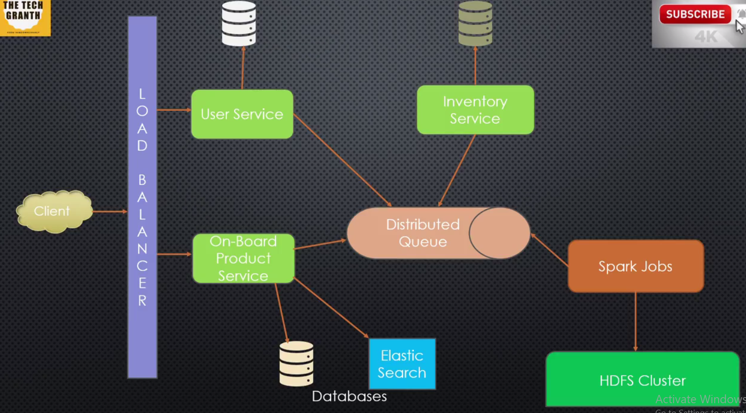

**User Service:**

So here first of all the User Service will talk to the client, here client could be anything, like mobile device or any other device. User service will on-board the user inside the website, so basically it will work like a gateway to the user. This User- Service should have the several functionality.

1. If user wants to add or edit several addresses to deliver then it should be able to add
2. Should be able to add credit/debit card information.
3. Should be able to show the previous order that the user already bought
4. Should have all the profile detail, like name, phone, email etc.
5. This user-service will have their own database and this could be RDBMS database like MySQL and in the database we should have the provision to have the data at least till 6 months or 1 year or archive the data and put it into HDFS database

So anything which is related to user then it should be routed through the User Service.

**On-Board-Product-Service:**

Now from the seller side if seller wants to sell their product then that product should be on boarded to our system and seller should be on-boarded via user-service.

Let’s say seller want to sell any mobile then seller user will go the that electronic category and here seller should have web page to insert all the detail related to mobile, like mobile technical configuration, price, warranty etc. Other detail like from where the product has to picked

And again On-Board-Product service should be connected to database to persist all the detail related to product apart from putting detail in the database, this service will put all the data into elastic search database so that it could be available if the user just to search the product and its related information.

So what kind of data base it should have for this service?

Since here it could have any type of product and it could have any shape, size, color and other parameter i.e. here will not have any fixed detail about the product and thus we would not have fixed schema for the on board product and thus this database should be document type of database, so we will take No SQL database like Mongo DB

**Distributed Queue:** Once we have product on boarded then [On-Board-Product-Service] should be able to send notification to Distributed queue where we can use Kafka just to take the real time information from the [O-B-P-S].

Why we need this Distributed Queue?

Once the [O-B-P-S] update the product detail then this information is required to many other services like **Inventory Service** which will store further all the detail related to product as soon as the product on boarded.

**Inventory Service:** This service will capture all the detail of the product from different seller, because one similar product can be sold by different vendors. So this inventory will keep all the information related to product, seller information and its quantity. So that later when product delivered successfully then service could provide the latest information of the entire product like its quantity and availability. And here again all the information should be persisted into database which could be any kind of RDBMS database

**Note:** We can have combined database for User Service and Inventory Service because here we are using RDBMS database only. But as we are working on Microservice architecture so better we would have its own database. And it is recommended also because we would have particular days when there we would have lot of traffic and in that case we just need to ensure the availability of the system.

Now the next service that we would dealing with a common service for all the service components which is nothing but [Spark job with HDFS cluster]

**Spark Job –With HDFS**

So this spark job can be written in java as Microservice which will listen to the Kafka Distributed Queue for getting all the information related to users, on-boarded product, and inventory information and will dump into HDFS cluster. Here it would have information of others information so we can use to show the recommendations to the other uses for buying the product. And further the data present inside HDFS can be used for analysis. So would work as Data Lake and would be the core of the system.

So far we have discussed about user-service, on-board-product-service, inventory service, now next we will talk about Search product service.

**Search product service**

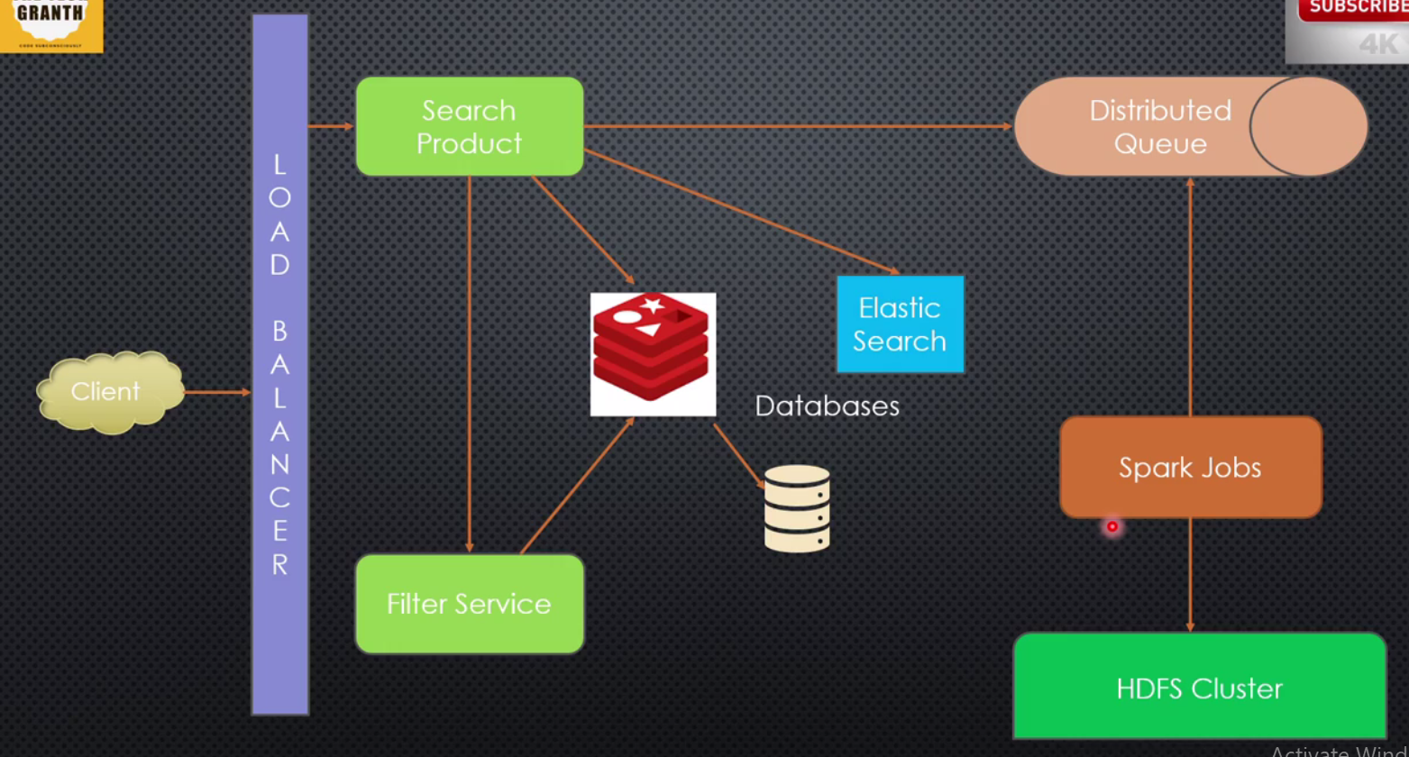

So if we want purchase product then either we can directly select the product from home page or dashboard page or directly go to the product category from the drop down and select the product or first we can search the product and we can select the product from search result.

So this search service will have different kind of end point like: category/device/mobile/Samsung and for fast accessibility we can use distributed redis. So based on the search data first it will try fetching data from redis DB and if it does not get the particular search data in redis then further it will hit the DB and will fetch the search data from the DB. And this redis will help on the particular occasion like festival season when the most of the people used to search the product. And another way we can search the product using elastic search which will help in searching the list of the product.

**Filter Service:** Once we get the result from the search then this result should be passed to the filter service and this filter service used to ensure that whether this particular product can be delivered or not like there could be a chance that product is available in the redis cache or database but this product could be delivered in particular place like Bangalore only and could not be delivered to other than Bangalore, that is why this filter service is required just to filter the search result product based on some condition or availability to the particular place. So here the filter service will try to fetch the data either from redis or database based on the particular location or address of the user of address of the seller. And there could be some other service which will check whether this particular product can be delivered to one warehouse to another warehouse or from seller to user location or not. So filter service is very useful service for user because let’s say any user already added the product in the cart but during proceed to purchase product is not available then it feels very bad to the user.

And one more thing the search service will keep on sending the search result to the distributed queue and this information can be used for analysis purpose and based on the search result system can send some recommendation to the user.

So this how our Search Service will work and after search we will select the product and now product will be available in the cart.

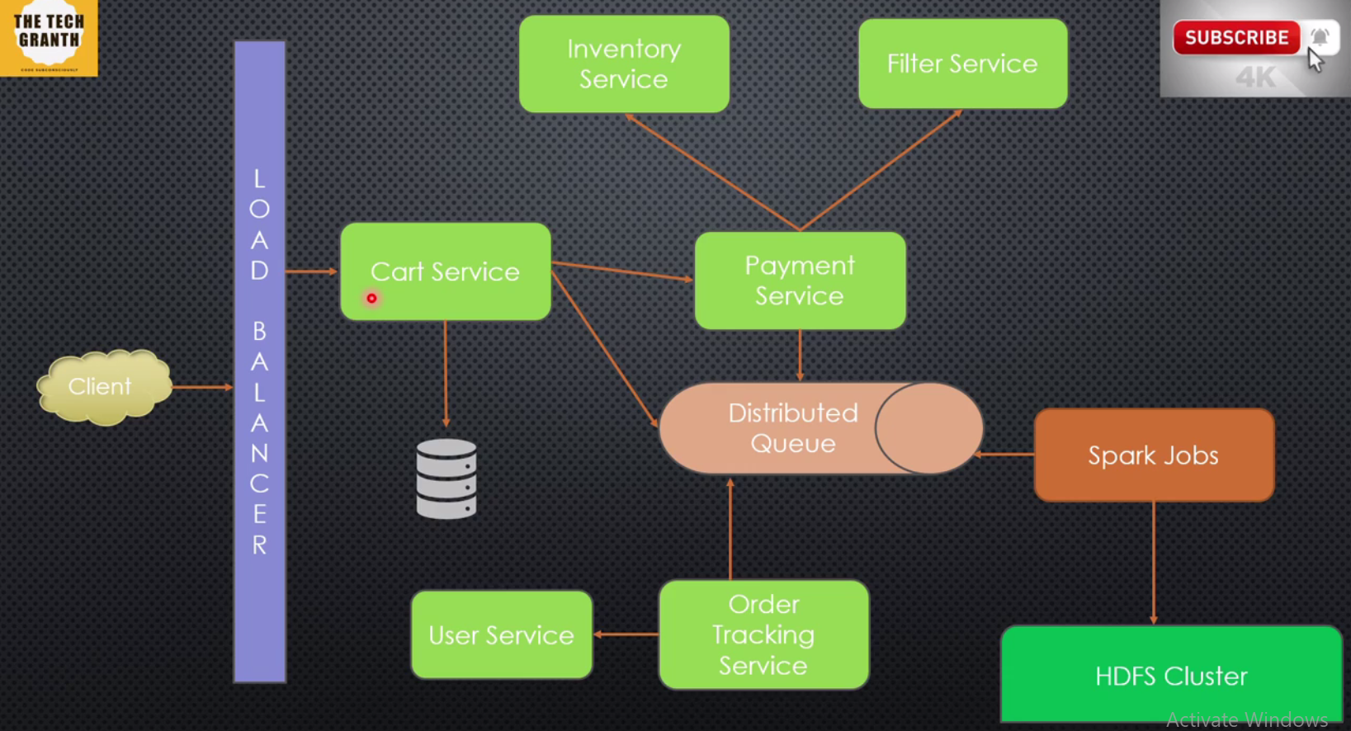

Now in this section let’s discuss about

1. Cart Service
2. Inventory Service
3. Payment Service
4. Order Tracking Service

As we can see that Cart Service will have their own database which will contain the info about the product that you have selected to buy. Because there could be a chance you have selected the product but did not go for purchase immediately so in this case product should be shown in the cart.

And again whenever we add the particular product into cart service then same information will go in distributed queue. And once we click on the button to purchase then request will go to payment service and now payment service will talk to inventory service and filter service both the reason being we have added the card detail today in the payment system but we will buy that product after few days and between these it might happen that someone has already bought that product and now product is not available in the inventory or in your nearby location, so payment service first will check with the filter service that this product is available in the nearby location or not and then it will talk to the inventory service and check whether the product is available in the inventory or not or either ways but it make sense if it talk to inventory first.

Once we got the information that yes the product is available and serviceable then payment service will ask for the detail of the payment and user can be redirected to payment gateway.

Once we have done the payment successfully then the same event goes to the distributed queue. If payment failed the again it will talk to the inventory and update the entry once again and release the blocked product and same failure information will send to distributed queue just to log the failure information.

And order tracking service will take the information (product order) from the queue for tracking purpose and will talk to the user service and user can see the all the tracking information of the ordered product.

The overall the system of e-commerce will look like as given below.

